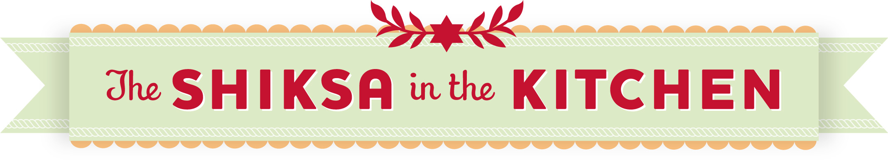

WHAT IS ROSH HASHANAH?

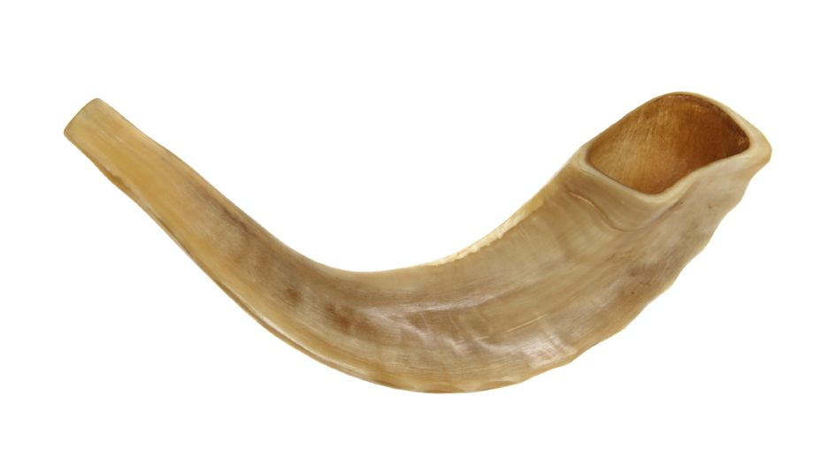

Rosh Hashanah is the celebration of the Jewish New Year. It’s a very important holiday on the Jewish calendar. It is the first of what we call the High Holidays (or High Holy Days), a ten-day period that ends with Yom Kippur—the holiest day of the Jewish year. On Rosh Hashanah, Jews from all over the world celebrate God’s creation of the world. Rosh Hashanah is two days long, and it usually occurs during the month of September.

During Rosh Hashanah, Jewish people ask God for forgiveness for the things we’ve done wrong during the past year. We also remind ourselves not to repeat these mistakes in the coming year. In this way, Rosh Hashanah is an opportunity to improve ourselves. It’s a holiday that helps us to become better people. And that’s a beautiful thing.

Jews from all over the world celebrate Rosh Hashanah in different ways. Holiday traditions can be different depending on where you’re from and how your family celebrates. A special prayer service is held at synagogue. The shofar, a special instrument made from the horn of a kosher animal (usually a ram), is blown during the Rosh Hashanah service. Tzedakah, or giving charity to people in need, is also part of the holiday. Good deeds are done and charity is given in the hopes that God will seal our names in the “Book of Life,” which brings the promise of a happy year to come.

Food is an important part of Rosh Hashanah. Many special foods are included in a traditional Rosh Hashanah meal as blessings. Sweet foods are eaten to symbolize our hope for a “sweet new year.” We enjoy “new fruit,” a fruit that has recently come into season but we have not yet had the opportunity to enjoy this year (often a pomegranate). The head of a fish is sometimes served, to remind us to be “like the head and not the tail”—so we’ll be leaders, not followers. The fish also symbolizes the translation of Rosh Hashanah, which means “Head of the Year” in Hebrew. A pretty, symbolic bread called challah is baked, sweetened with raisins and braided into a round shape. Apples are dipped in honey, again symbolizing sweetness. All of these traditions are important, because they help to connect us to the deeper meaning of the Rosh Hashanah holiday.

If you’d like to wish somebody a happy Jewish New Year, you can say “L’Shanah Tovah,” which is Hebrew for “A Good Year.”

